Prototype of SANYO

1. Login screen
2. Create new Project

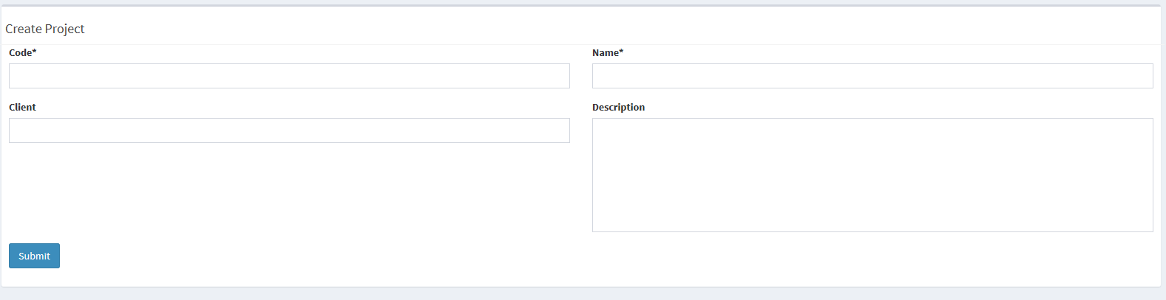

1. Create new sub project if any

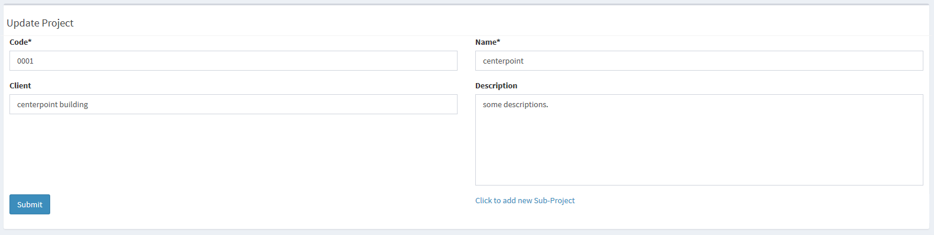

Click on hyperlink to create sub-project like Zone A, Zone B

1. Assign new Regions